Based on the above analysis, we have demonstrated the difference between market share. Then, we want to go further to see the major DRG where the monopolistic practices are more pronounced. In order to find a pair of high and low-end DRG, we run a program to generate the Herfindahl-Hirschman Index (HHI), which stands for the monopoly of hospitals in providing services for the specific DRG groups. We calculated the HHI score for governmental and commercial groups respectively. According to the difference in HHI score between these two groups, we get the lowest difference from DRG 470, which is classified in musculoskeletal MDC. When Patients who suffer from Major joint replacement or reattachment of lower extremity in the Medicare group (Table 1a), they were distributed in our 5 divided area, 433 patients from Burlington, 191 from Barre, 104 from Newport, 155 from Randolph, 302 from Rutland, and most of them received their treatment in their region, other than 81 of patients from Burlington, 13 of patients from Newport, 21 patients from Randolph, 66 patients from Rutland, 36 of patients from Barre were transferred.

Additionally, Although the number of patients with DRG 470 in the commercial group is 500 less than in the Medicare group, there is still a small amount of patients traveling to other regions to receive treatment. Majority of patients suffering from Major joint replacement or reattachment of lower extremity were coming from Burlington,taking up to almost half of the total patients.

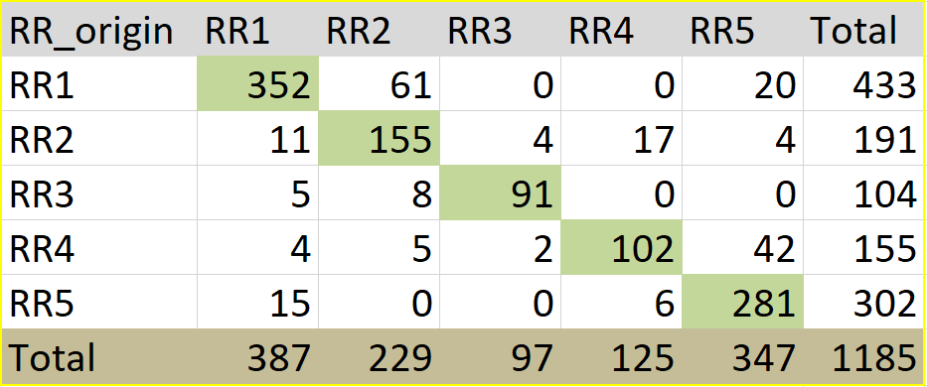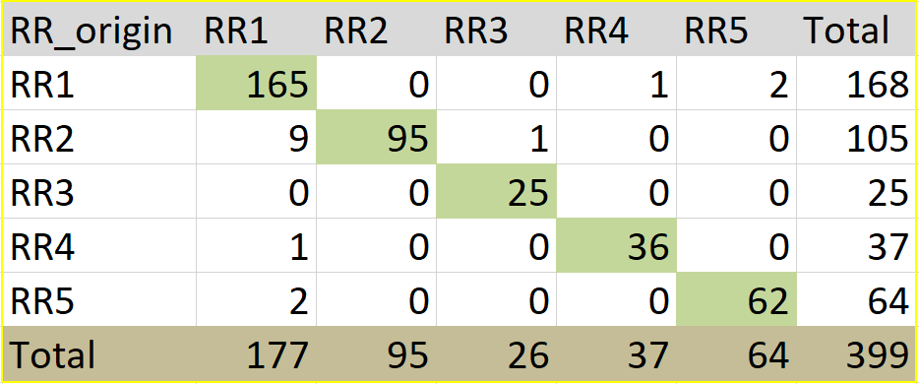

**Table 1a Government * low-end Table 1b Government * high-end**

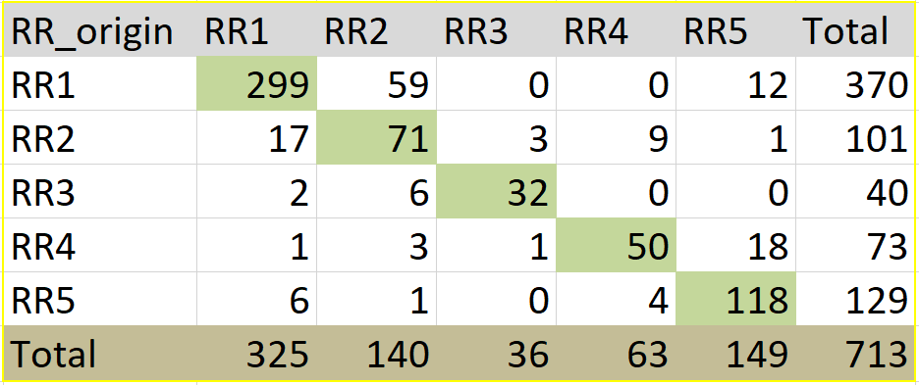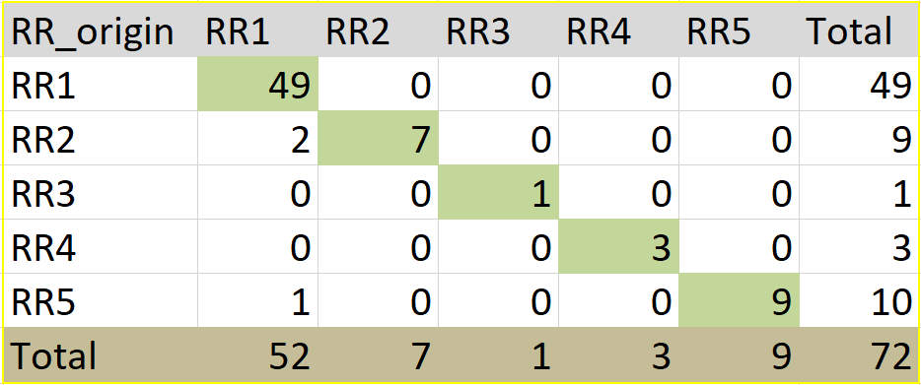

**Table 1c Commercial * low-end Table 1d Commercial * high-end**

We get the high HHI value from DRG 189, which is a more complex disease: Pulmonary edema & respiratory failure, classified in respiratory MDC (Table 1b). Among the patients, 399 of them incurred government insurances, 72 patients with commercial insurances. For patients in the Medicare group, majority of them were from Burlington and Barre, and most patients from Burlington stayed in Burlington, Northwestern Medical Center, University of Vermont Medical Center, or Porter Medical Center, to receive treatment.

Moreover, there are 72 patients suffering from Pulmonary edema & respiratory failure in commercial groups.Majority of patients were from Burlington and received treatment in Burlington, other than one patient transferred to Randolph and 2 patients transferred to Rutland.

In Summary, although the patients suffering from DRG 470 did not always visit hospitals in their referral regions, they tend to have no preference in hospitals outside their regions. In other words, there is no ‘magnet’ RR on Major joint replacement or reattachment of lower extremity. On the opposite, patients in DRG 189 tend to stay in their area, however, RR1 has appealed to some out-region patients.

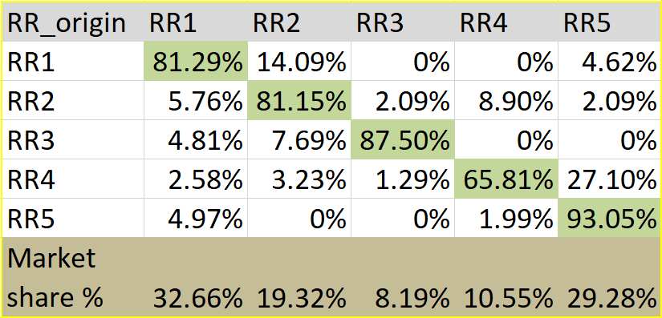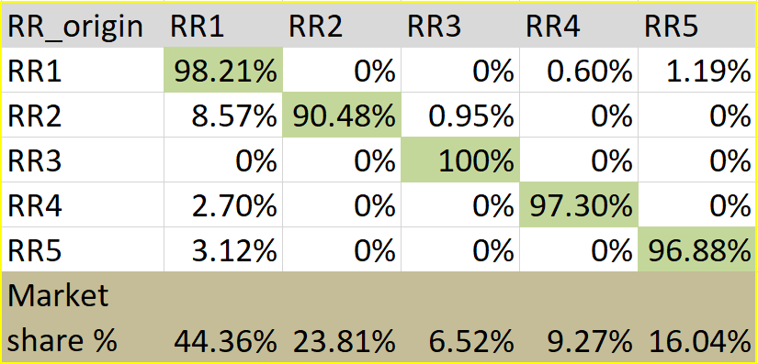

**Table 2a Government * low-end Table 2b Government * high-end**

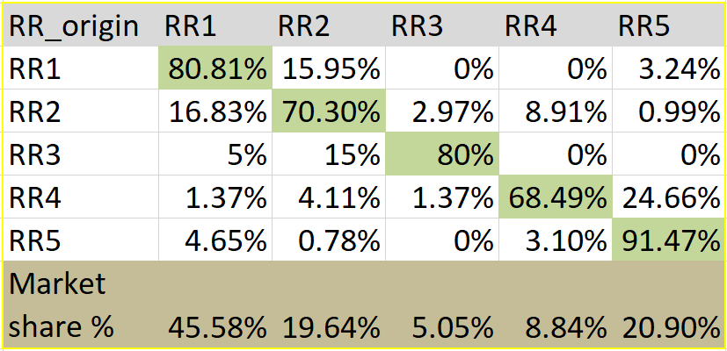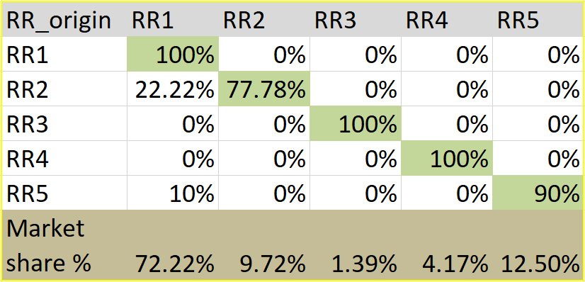

**Table 2c Commercial * low-end Table 2d Commercial * high-end**

After looking at the differences in numbers, we want to go further to see the distinctive difference in their market share (Table 2a-d). According to Table 2a, we can see that the market share is almost evenly distributed among 5 revised regions and there is no obvious high-degree monopolistic for Major joint replacement or reattachment of lower extremity. Looking at the diagonal element of the O-D matrix, the percentage of the care that was rendered locally is around 80% to 90%, except Randolph with lower proportion 65.81%. The diagonal number for patients suffering from Major joint replacement in commercial groups is distributed unevenly and slightly lower,mainly concentrated between 70% to 80%, except Rutland with higher rate 91.47% . In contrast, the O-D matrix remains heavily concentrated in the diagonal elements with very few leakage to other areas for Pulmonary edema & respiratory failure Medicare group. localized care reached approximately 97 to 100 % for our 5 revised regions, other than slightly lower in Barre with 90.48%. It’s more pronounced for commercial groups, with 100% localized care weight in Burlington (RR1), Newport (RR3)and Randoph (RR4), 90% in Rutland (RR5) and slightly lower in Barre with 77.78%.

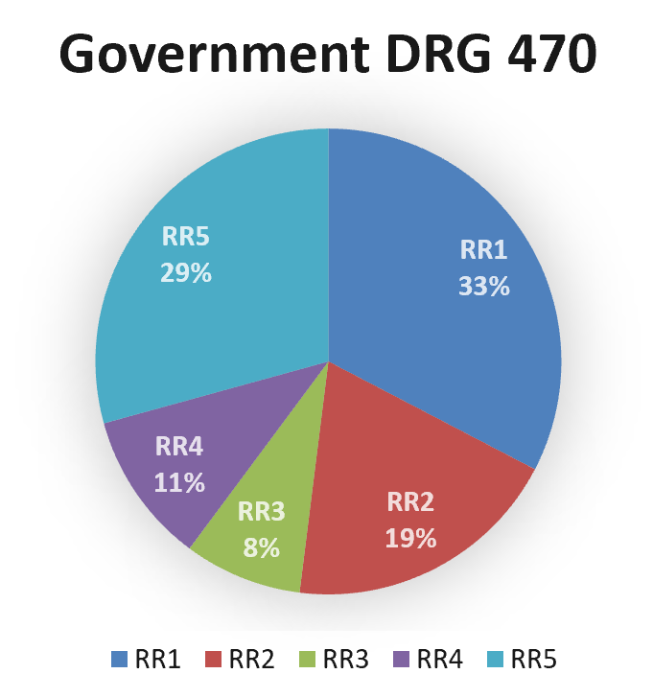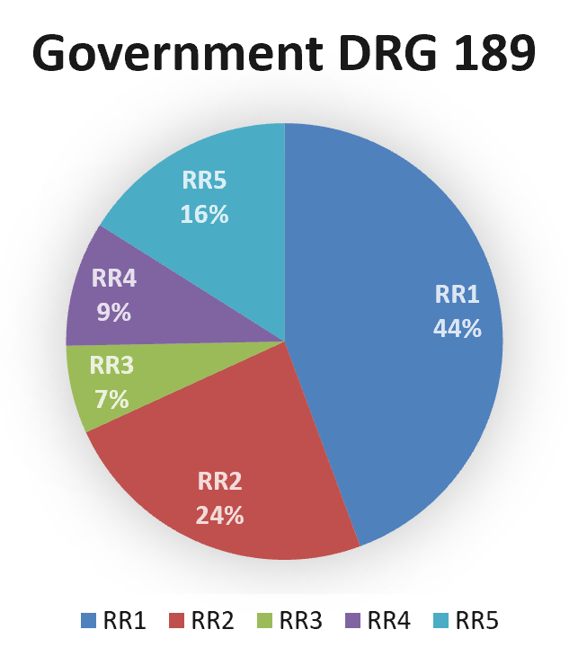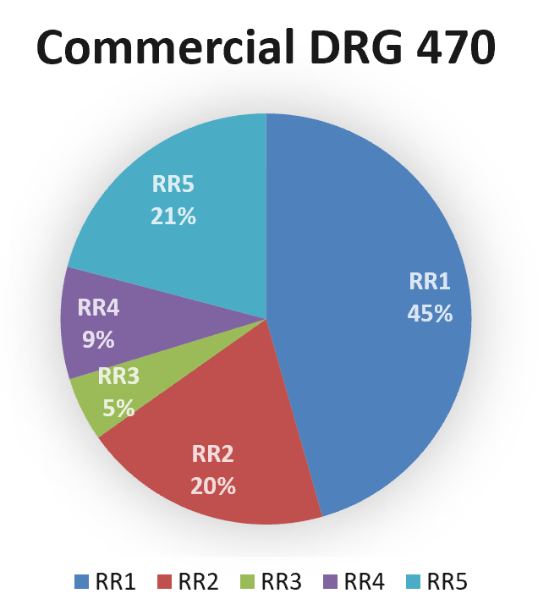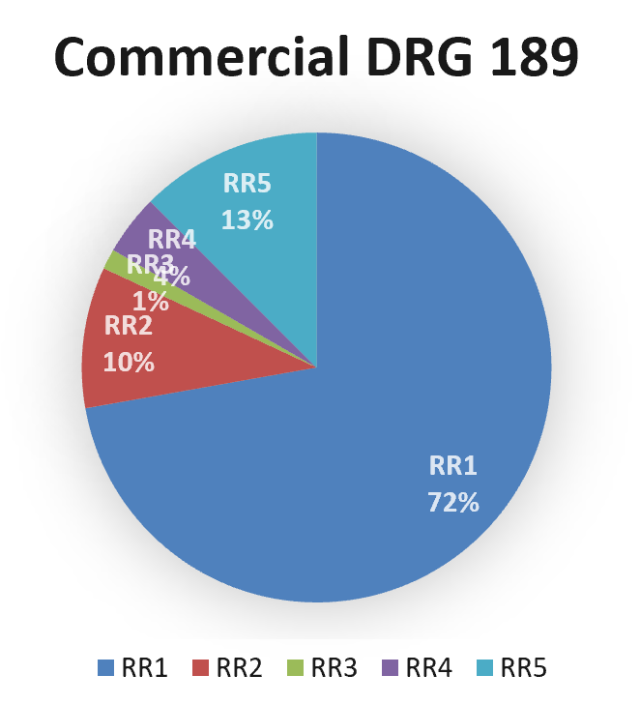

University of Vermont Medical Center, largest hospital of state, was located in Burlington. It provides advanced care to approximately one million people in Vermont and northern New York. Its professional and capacity for patients attracts a lot of patients from other regions. According to the 4 O-D matrix, Burlington accounted for the largest market share in 4 different situations. Joint replacement is a procedure of orthopedic surgery in which an arthritic or dysfunctional joint surface is replaced with an orthopedic prosthesis.Joint replacement surgery is becoming more common with knees and hips replaced most often. About 773,000 Americans had a hip or knee replaced in 2009. With low- degree of monopolistic competition, the market share is almost evenly distributed, Burlington still holds the largest market share with 32.66%, but closely followed by Rutland with 29.28%. Barre ranked third in market share, taking up 19%, as same as the combination of Randolph and Newport.When patients suffering from Pulmonary edema & respiratory failure were analyzed in the medicare group, the market share for Burlington slightly increased to 44.36%. The portion of patients Barre received does not change much, with a 5% increase, still taken up almost one fourth. When it turns to Pulmonary edema & respiratory failure in commercial groups,the portion in other regions experienced a dramatic decrease, other than Burlington.Barre cut patients treatment in half, from 24% to 10%. The market share for Newprt and Randolph decreased to less than half of the Medicare group. In contrast, Market share for Burlington doubled for commercial group.Through the comparison of market share between commercial and government groups, we can conclude that the private insurance payers are more willing to transfer to hospitals with better medical resources, and this is the reason why Burlington took up 72% in the market. What’s more, compared with patients suffering joint replacement in commercial groups, which Burlington make up 45 % of the market, the treatment of Pulmonary edema & respiratory failure has apparent advantages of monopoly. Because of the strict requirement for Pulmonary edema & respiratory failure treatment, not all hospitals are eligible for serious situations, some patients prefer to transfer to hospitals with high quality medical resources. In conclusion, it’s clear that private insurance payers and patients needing high-end care are more likely attracted by the high quality medical resources.